**Experiment 13**

**Aim:** Execution of basic docker commands.

**Procedure:** Here the commands will be executed on redhat 8, for running docker on this system we must execute the commands via the root user.

**Commands:**

**1)** docker images: The following command will display all the docker images that have been downloaded or created. To run the command write ‘docker images’ on the terminal

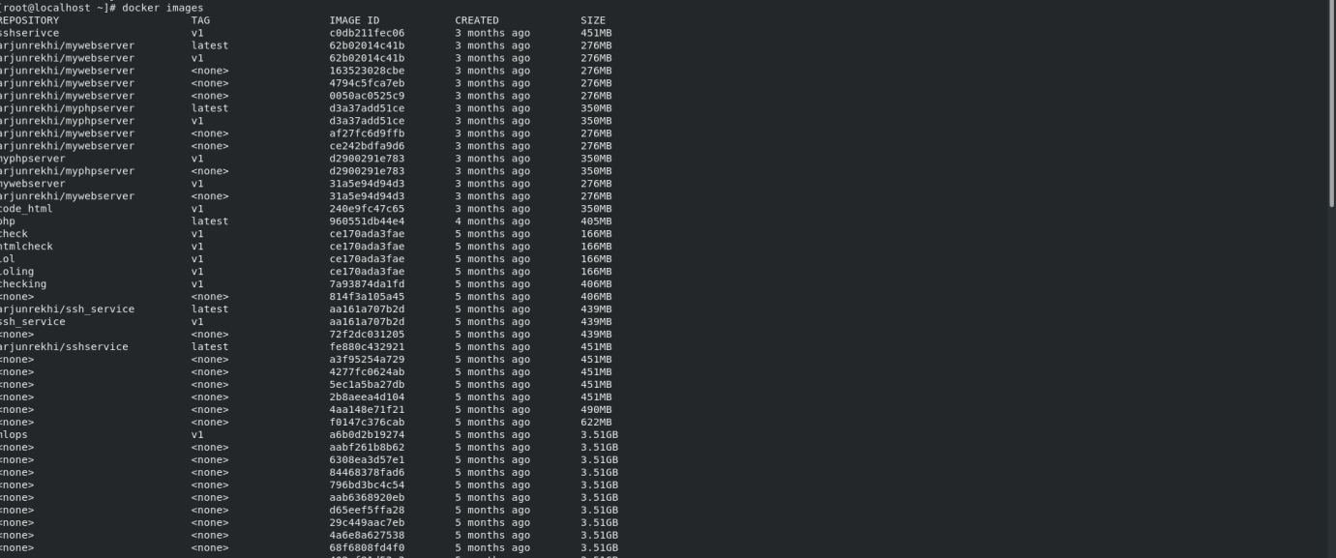

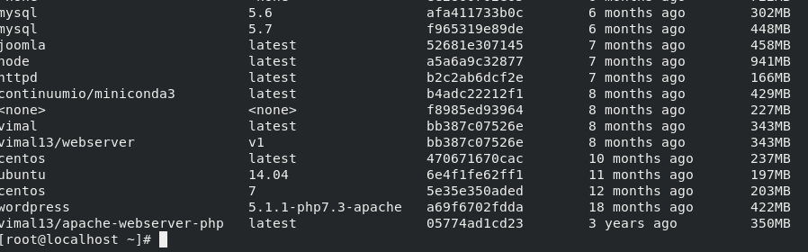

**2)** docker search: The following command will search dockerhub for images. To run the command write ‘docker search [what image you want]’

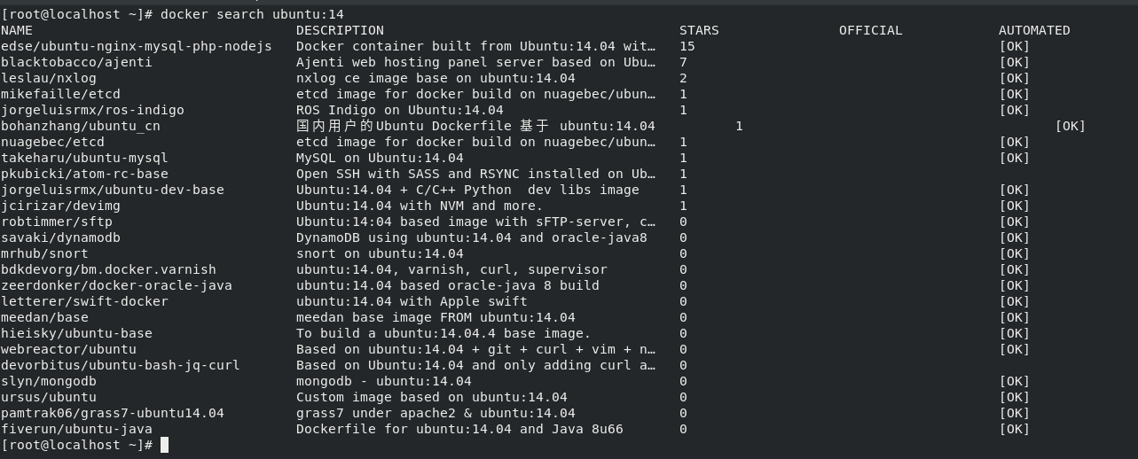

**3)** docker pull: The following command will pull images from dockerhub which can further be used to create containers.

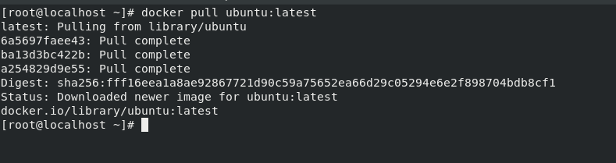

**4)** docker ps: The following command will display all the running containers.



**5)** docker ps –a: The following command will display all the containers created whther running or stopped.

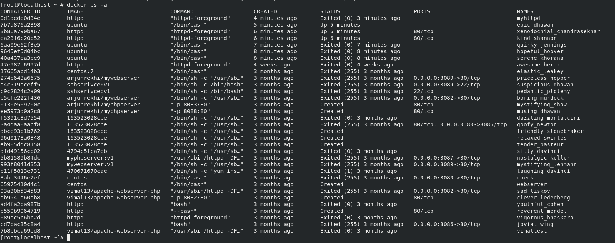

**6)** docker run: The following command is used to create containers. There are a options that can be used with this command, some of them are:

**a)** docker run [image name]: The following will only create the container and start it.

**b)** docker run –d [image name]: The –d will run the container in the background.

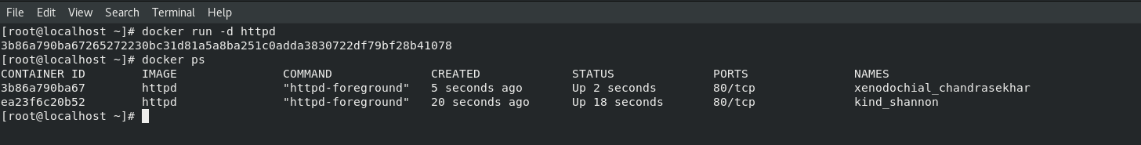

**c)** docker run –it [image name]: The –i option is used to make the container interactive and –t is used for attaching the container’s terminal.

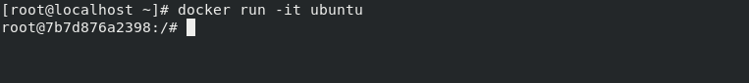

**d)** docker run –p [port number:port number] –name [name] [image name]: The –p option is used for NAT aspect. Here if the request comes on the base machine it will redirected to this port which is of the container.

--name: is used so that we can assign a name to the container created.

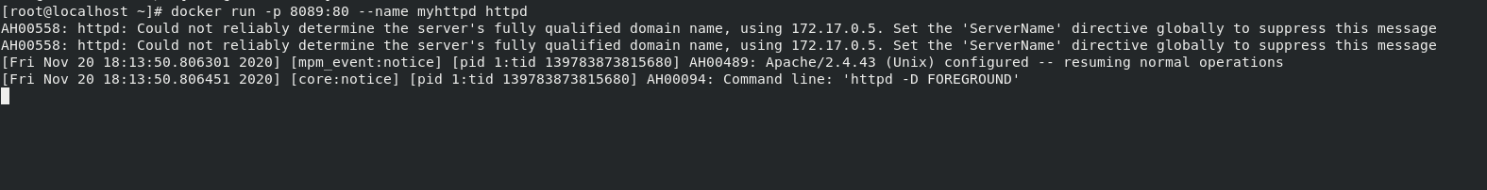

**7)** docker inspect: The following command is used to inspect the container that has been created. To run the command ‘docker inspect [container name]/[container id]’.

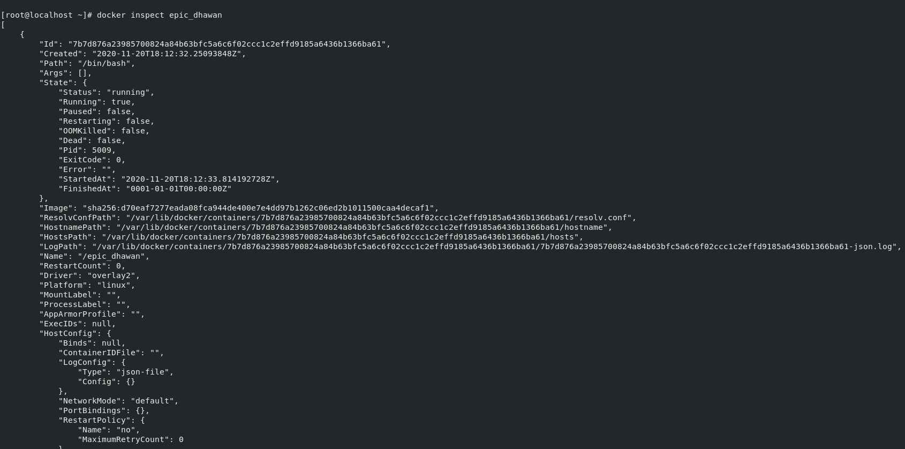

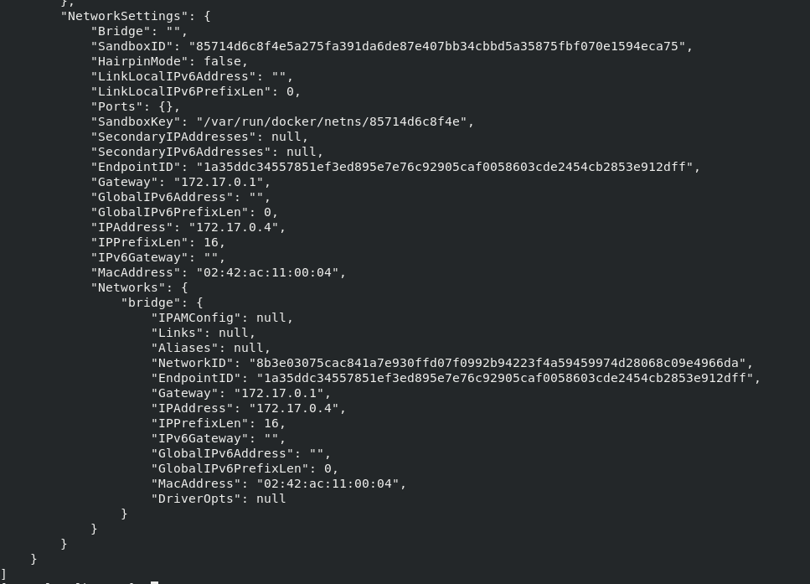

**8)** docker stop: The following command is used to stop a running container. To run the command ‘docker stop [container name]/ [container id]’.

**9)** docker start: The following command is used to start a container that has already been created. To run the command ‘docker start [container name]/ [container id]’.

**10)** docker attach: The following command is used to attach the container’s terminal after it has been started. To run the command ‘docker attach [container name]/ [container id]’.

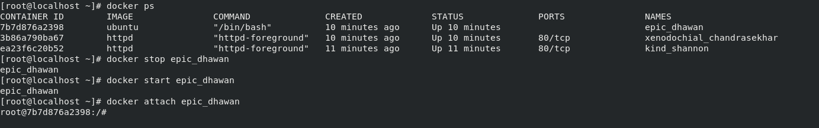

Submitted by:

Arjun Rekhi

500068109

R171218028